Ignite To NPE V2 Sync

When using the Ignite to NPE v2 Sync the following items will be synced to the NPE V2 system from ignite:
- Campaigns
- Campaign donations.
- Event donations.
- Fundraising page donations.
- Contacts (i.e. donors).

The following steps will outline how to configured Ignite to sync to NPE v2.
- First after logging in, click on your username in the top right and select My profile.
- Next click on the tab named “Sync to NPE V2” where you will need to provide the API key from NPE V2.
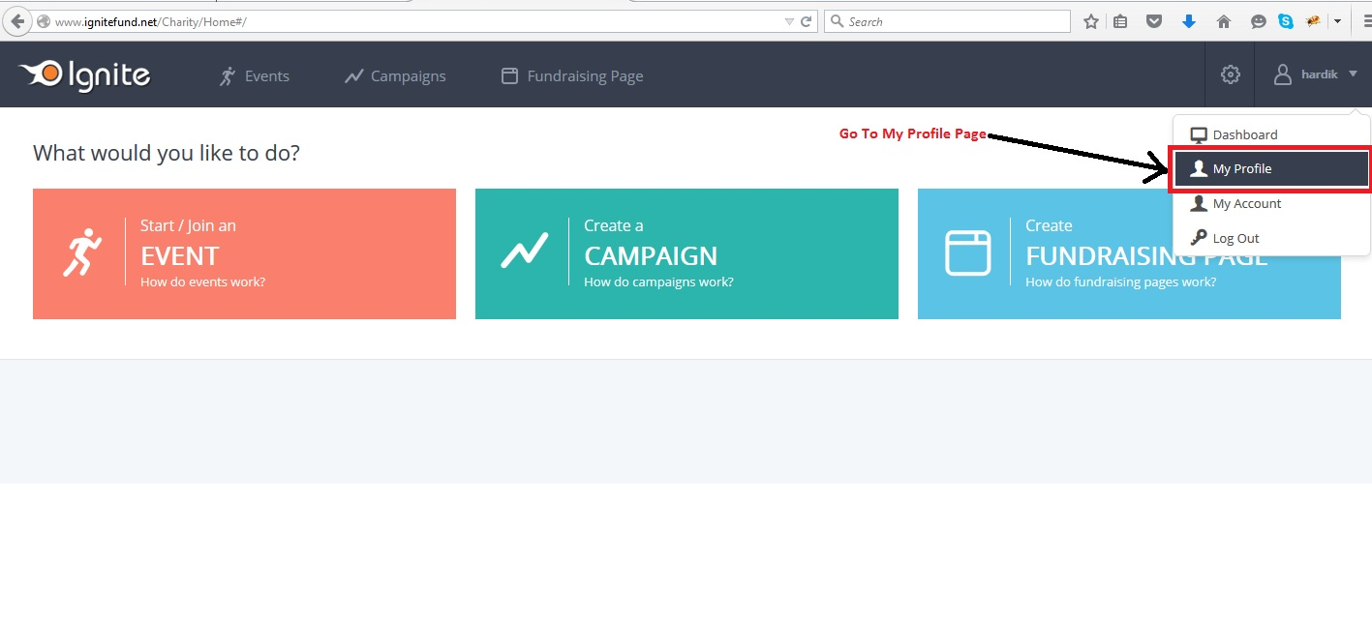

Note: ONE API KEY WILL BE USABLE ONLY BY ONE ORGANIZATION. MULTIPLE USERS WILL NOT BE ABLE TO USE THE SAME API KEY.

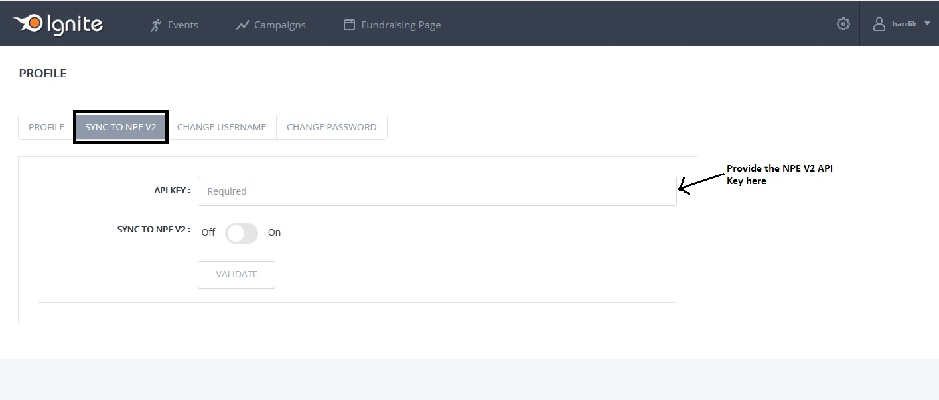
- The NPE API key can be retrieved by logging into your NPE account, clicking on your username and going to Organization Info.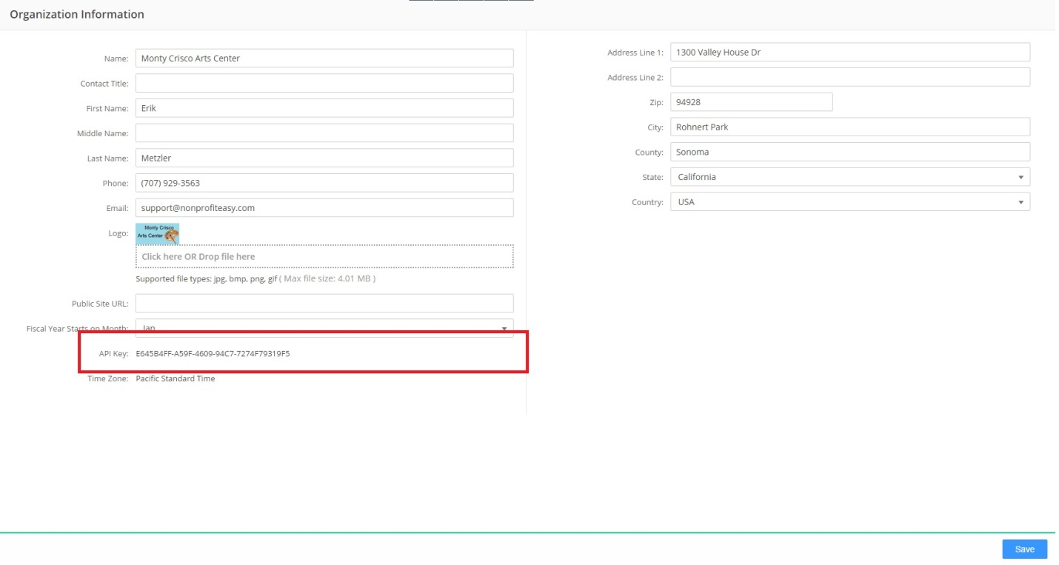
- After entering the API key and setting the “Sync to NPE v2” option to On, click on Validate.
- If the API Key is valid then the system will prompt you to select the default “Fund” and “Gift Source” configured in NPE V2 that Ignite will sync to.
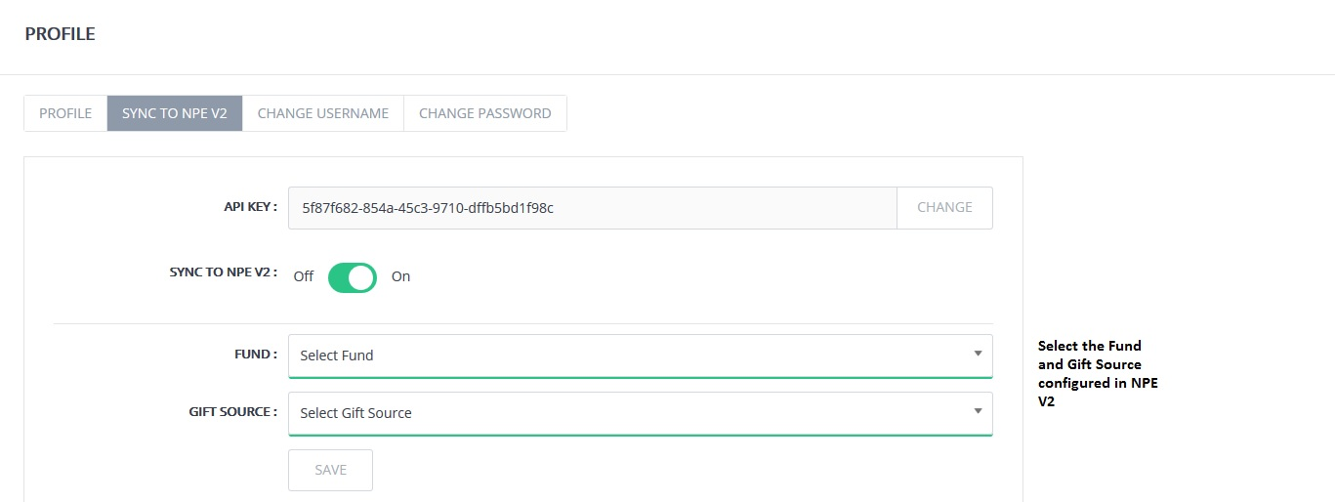

- Once saved these settings will be replicated for all campaigns and events in ignite, but can be changed on a per project basis.
- To change the Fund and Gift Source for a project, edit the project you wish to modify and click on “Sync To NPE V2” in the left hand menu.
For campaigns
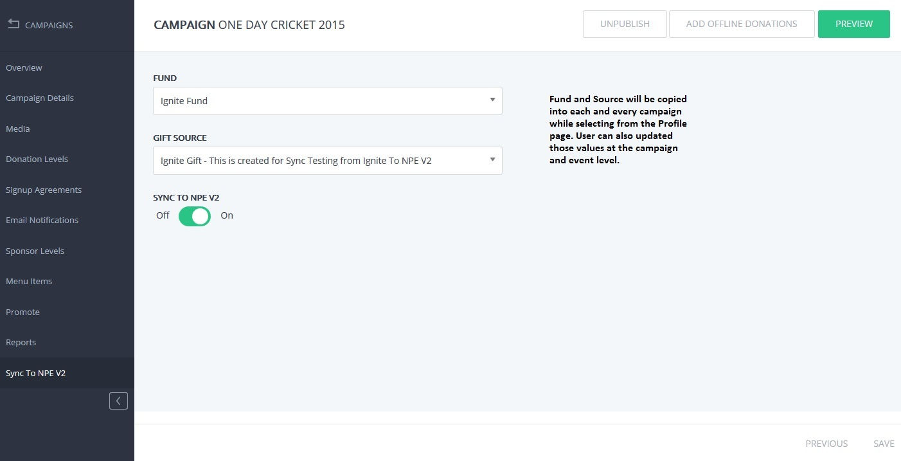

For Events
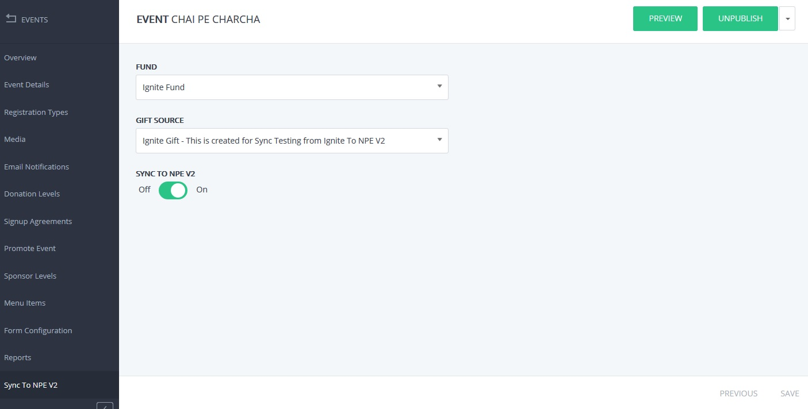
- From here you can specify the specific Fund and Gift Source for the Project and click Save in the lower right when complete.

