HOW CAN MAIN EVENT/CAMPAIGN OWNER ADD OFFLINE DONATIONS?
-If you receive cash, check or other types of donation, you can input those as offline donations by:

- Click the dropdown beside the Publish/Unpublish button
- Click Offline Donations

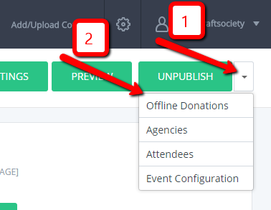

- Click Add New Donation
- A pop up window will show up wherein you can fill out the necessary fields for the offline donation.
- Once you’re done filling out, click Save & Add New or Save & Close

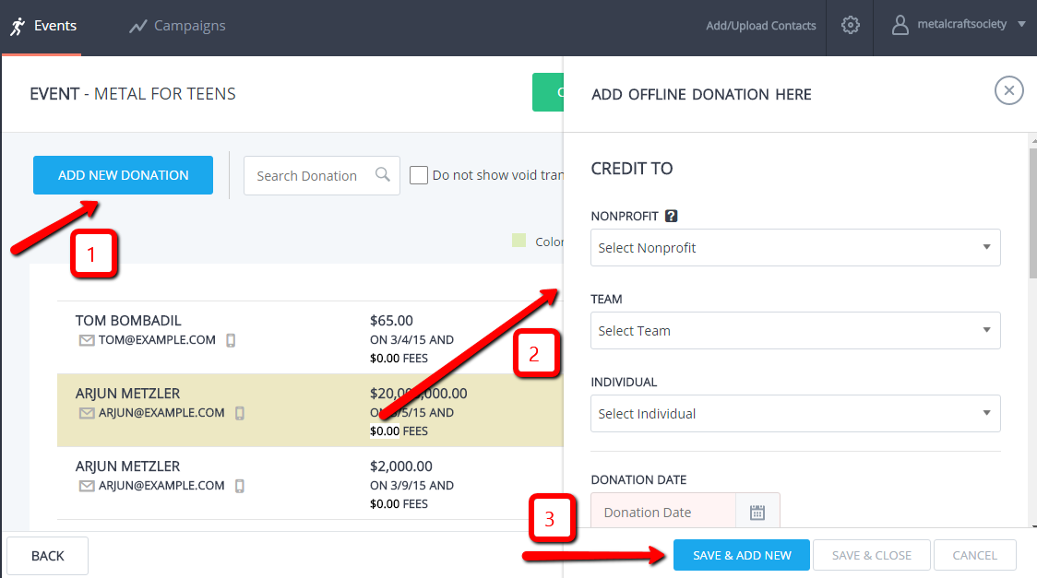

*Notes:
- Email is used as unique identifier so if same email is used for two or more offline donations then they would copy the same first and last name of the last offline donation you entered which again has the same email address as the others.
- If an email is added, then an acknowledgement will be sent to the donor.
- To track additional information, click on “More”.

Do you want your offline donations reflected in the goal thermometer? If so, you can do this by going to:

- Click the dropdown beside Publish/Unpublish
- Click Event Configuration
- Toggle on “Include offline donations on goal thermometer”

HOW CAN FUNDRASIERS (NONPROFITS/TEAMS/INDIVIDUALS) ADD OFFLINE DONATIONS?
-If you receive cash, check or other types of donation, you can input those as offline donations by:

- Click the Offline Donation button found on the upper right side

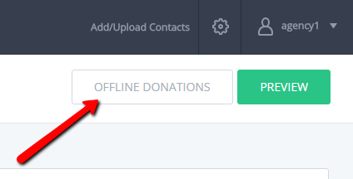

- Click Add Offline Donation

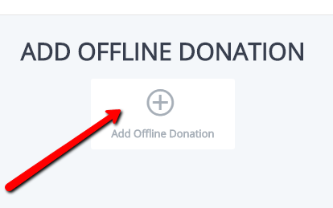

- A pop up window will show up wherein you should fill out the fields for the offline donation.
- Once you’re done filling out, click Save & Add New or Save & Close

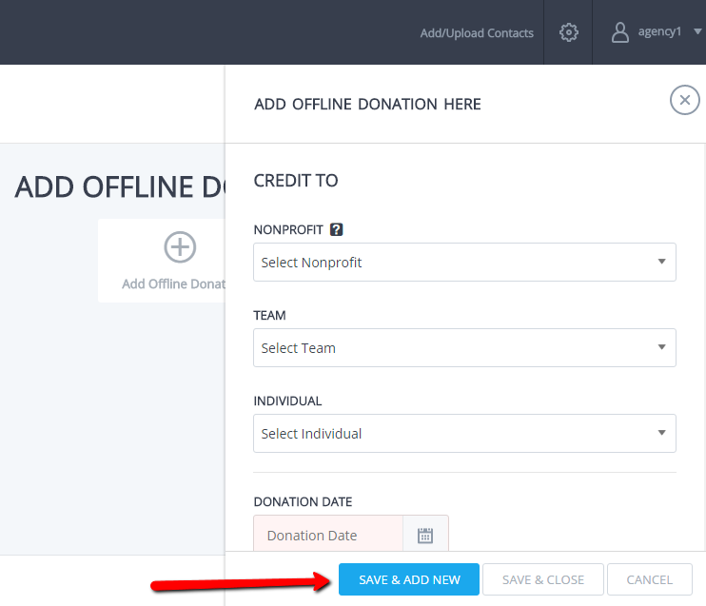
*Notes:
- Email is used as unique identifier so if same email is used for two or more offline donations then they would copy the same first and last name of the last offline donation you entered which again has the same email address as the others.
- If an email is added, then an acknowledgement will be sent to the donor.
- To track additional information, click on “More”.

Do you want your offline donations reflected in the goal thermometer? If so, you can do this by going to:

- Event/Campaign Overview tab
- Toggle on “Include offline donations on goal thermometer”
- Click Save
*Note: Your menu items may look slightly different depending on your login (i.e. Event/Campaign fundraiser will have more options than others).

HOW TO VOID OR REMOVE AN OFFLINE DONATION?
To void donations:

- Click the dropdown beside the Publish/Unpublish button
- Click Offline Donations

- Click the void icon (beside edit) for the offline donation you want to remove.

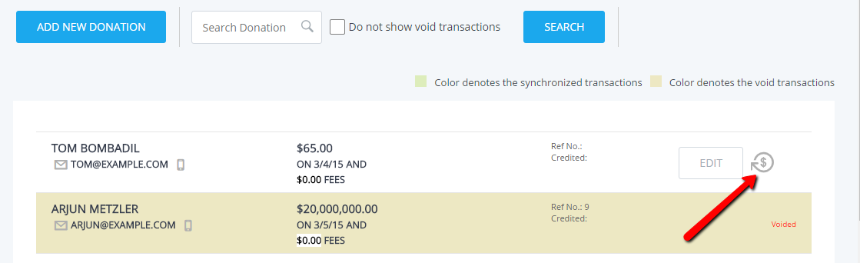

- A pop up box will show up to make sure if you really want to void the offline transaction. Click OK if you are sure.

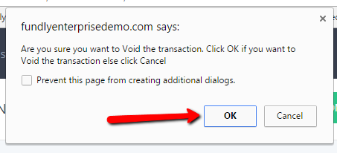
*Note: Once void, your donations will show up in a different color.

HOW CAN ADMIN SEE THE LOGS FOR RESET PASSWORD AND RESEND IF NECESSARY?
- Only the main campaign/event owner and the nonprofit fundraisers have this feature. They can see all the fundraisers under them who have reset their password, the temporary password given to them and resend the email if needed.

- Click the Global Configuration gear
- Click Show Reset Password Log

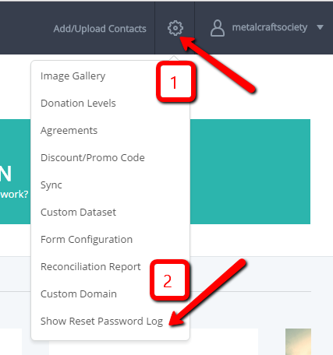

- You will see the history of all the fundraisers who have reset their password along with their other information like the username and the newly generated temporary password that was sent to them. The status is shown as:
- “Pending” if they have not changed their temporary password yet
- “Success” if they have logged in to their account and changed their password to replace the temporary password.
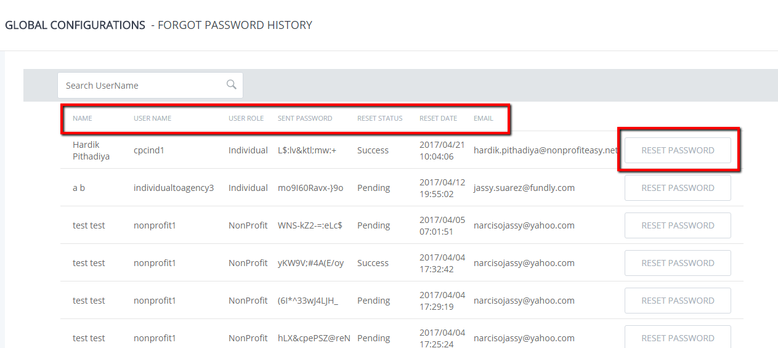

*Note: If you wanted to resend the email for temporary password, click on the RESEND PASSWORD button.

HOW TO INCLUDE SPONSORHIP RAISED IN GOAL METER?
-Sponsorships, along with donations can be included in the goal meter on the public site so people can see how close you are to your goal. Donation and sponsorship will be displayed in separate colors on the goal thermometer.

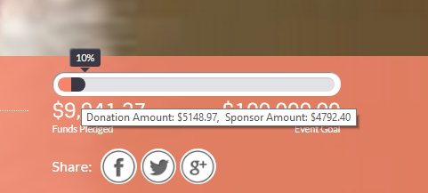

- Click the drop down beside the Publish/Unpublish button
- Click Event Configuration
- Enable “Include Sponsorship amount in fundraising meter”
- Click Save

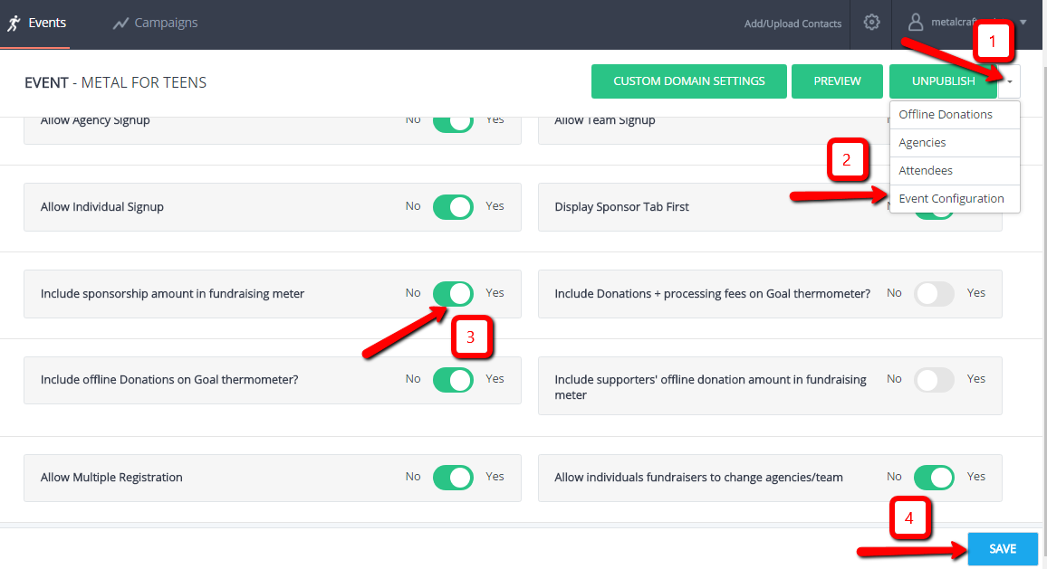
HOW TO RESEND EMAIL Notifications (such as donation acknowledgement, event registration details, fundraiser’s sign-up details and more)
-Resending an email notification sometimes is needed especially when someone has not received it. You can resend these emails to the same email address or put a different one.

- Once you are in the event/campaign, hover your mouse over the box and click the edit (pencil) icon.

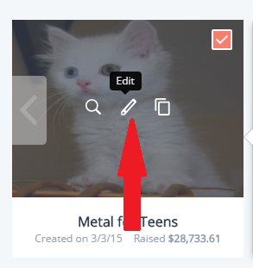

- Got to Email Notifications tab
- Click the drop down beside Edit
- Click View email log

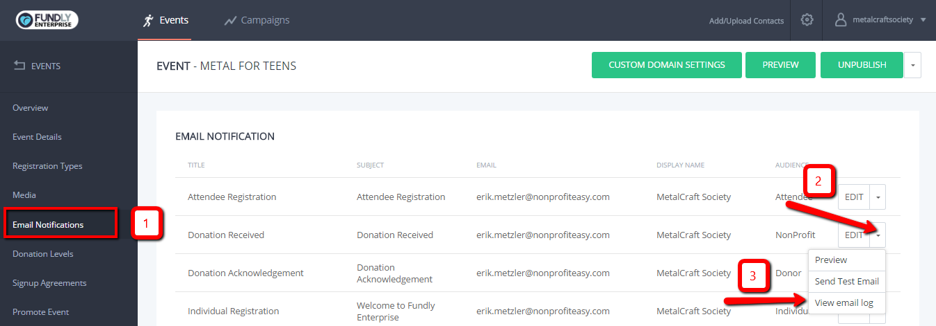

- Click the resend icon

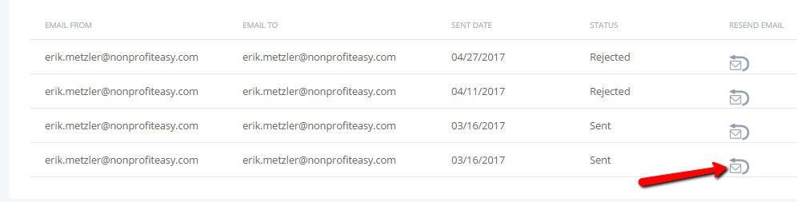

- A pop up window will appear where you can see the content of the email. Scroll down to the bottom. You will see the receiver’s email, you can leave it as is or enter a different email address in case the person has another email address which he/she prefers to receive the email.
- Click Resend Email
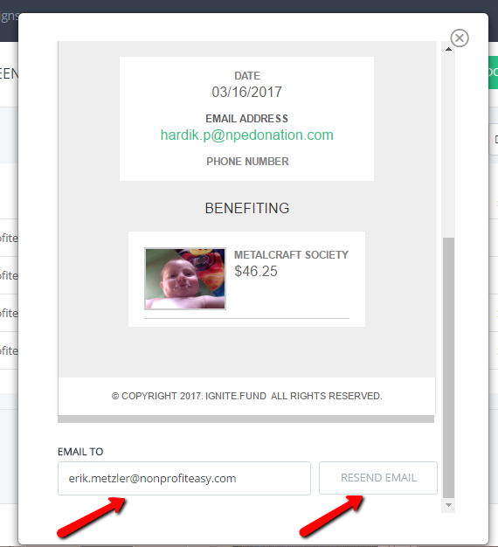

HOW TO EDIT UPLOADED PICTURES IN MEDIA

- Once you are in the event/campaign, hover your mouse over the box and click the edit (pencil) icon.

- Go to the Media tab
- Choose the picture you want to edit from the Banner or Photo Gallery
- Hover your mouse over the picture
- Click Edit (pencil) icon

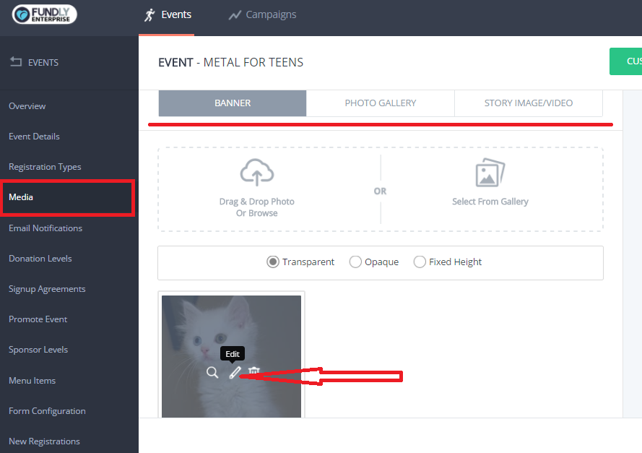

- A pop up window will show up where you can edit the pictures like resizing it, cropping, adjusting the brightness, put stickers, add frames, etc…

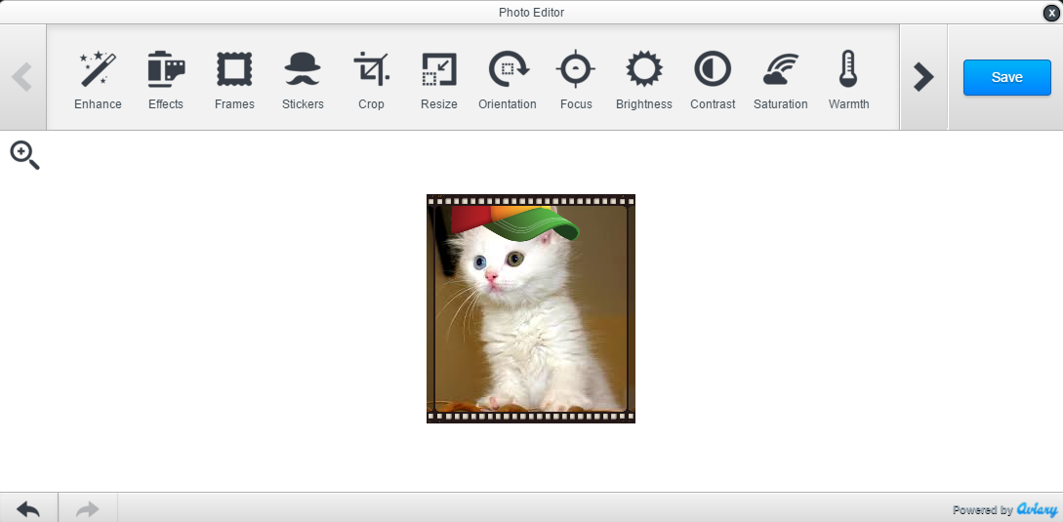

- Click Apply once you’re done editing the image.
- Click Save

HOW TO HYPERLINK A TEXT

- Highlight the text of your choosing

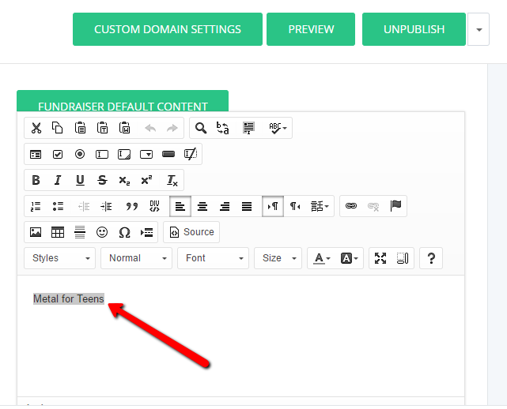

- Click the "link" icon (inverted 8)

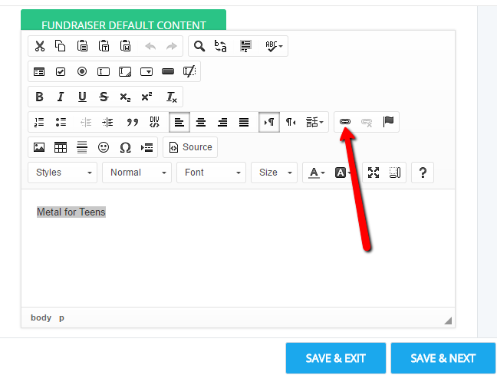

- Paste the URL of the site you want to link with the text
- Click Ok

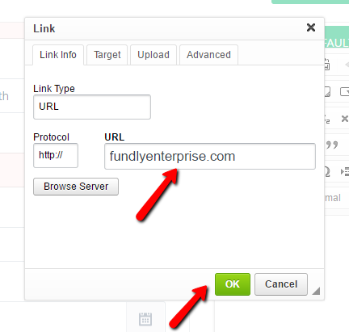

- You can go to the next tab (Target tab). Click the drop down and choose New Window if you want the link to open in a new window.

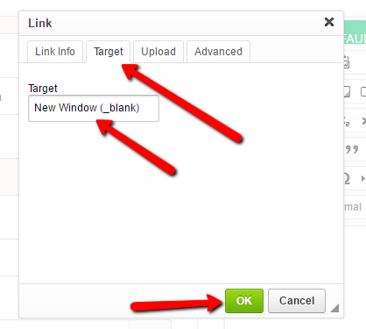

- Click Ok
- Lastly don’t forget to click Save & Exit or Save & Next so the changes you’ve made won’t be lost.

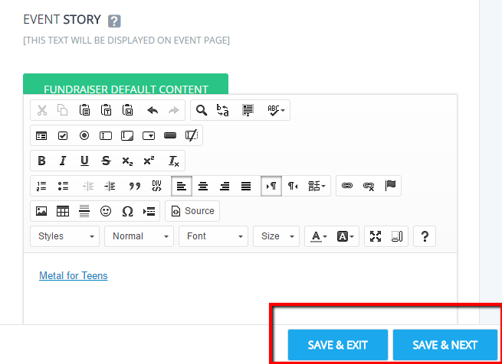

HOW TO EXPORT A DONATION REPORT

- Once you are in the event/campaign, hover your mouse over the box and click the edit (pencil) icon.

- Go to the Reports tab
- Click the Donations tab
- Click Export to only get the report of a certain page or filtered dates
- Click Export All if you want to get all the results of the online donations since the event/campaign started
- Toggle on the “Show Offline Donations” then click Search to export only the offline donations.

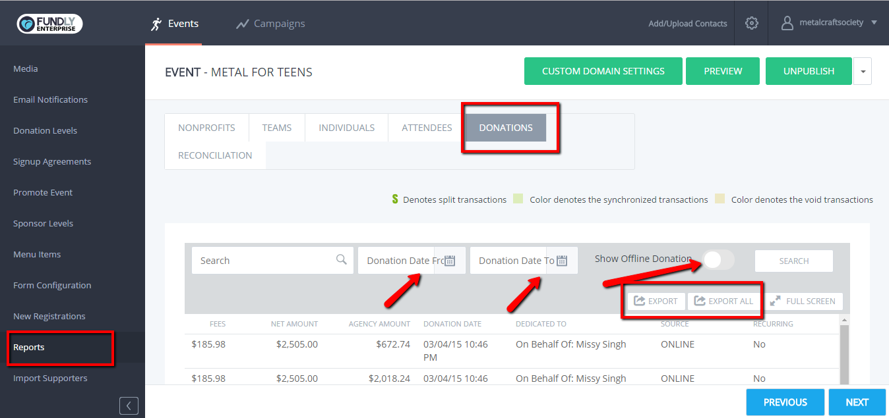

*Note: Your menu items may look slightly different depending on your login (i.e. Event/Campaign owner will have more options than others).

